*ScoreExchange Inc.*

*04.22.2015*



1. **Executive Summary**

More and more people start to practice and play the piano nowadays, and there is a potentially huge market for those piano lovers -- our business idea was thus inspired and we are willing to create an online society for these people and try to change the traditional way of playing the piano and socializing among music fans. In the past, learners always needed to carry a stack of piano scores whenever they want to practice playing or just run into a piano to have fun, which is pretty burdensome. Our app would help piano players to get rid of these burdensome paper-scores with neat and convenient digital-scores. Additionally, our app would also support customers to consult and possibly download these piano scores on their tablets at any time, further establishing a great online society for piano lovers to share their ideas, become friends and communicate with their own piano videos, etc. The target market of our app includes both individuals and corporations such as music schools or the music department in universities, because our app would be designed to provide the features such as adding notes or marking on the scores to effectively help the teaching process. Our competitive advantages are that this innovative app would not only greatly enhance the traditional way of learning piano, but also create a new environment and amazing approach for piano lovers to get acquainted and communicate with each other.

To effectively and successfully implement our business plan, we have established a well-formed team, in which everyone has a great sense of responsibility and cooperation. More importantly, many of us have a passion for music, especially for the piano, a background knowledge of business management and previous experience in designing and developing a mobile app. Talking about the offering we might need for implementing our business plan, we would initially need a rough amount of 50,000 dollars to get our app fully operated and all the relevant works done, and the cost of copyright for all scores in our database may vary based on the cooperation with relevant companies and the dealing process of legal issues. With that being said, we are pleasing to offer 40% share of our company in exchange of this generous investment and would be open to negotiation for more details in the future.

1. **Industry, Company, and Product**
2. **Our Inspiration**

We are targeting a linkage between the music industry and mobile applications. There is a potentially huge market for those piano lovers if we could create an online society for music. We are inspired by the idea of trying to change the traditional way of learning piano.

1. **A mobile software product**

We are aiming at creating a product which is a platform for piano fans to share scores, a society for piano lovers to exchange ideas, as well as a tool for educational usage.

1. **Entry and Growth Strategy**

Our mobile app is an innovative product. We give two ways of purchasing, payment and built-in purchase. During the first year, we intend to make our product own 40% of the market share. More additional features and larger score databases are our current goal of expansion. There is a large amount of students and piano fans all over the world. And the demand for that relates to music and education, since more and more people use electrical devices and online database.

1. **Market Research and Analysis**
2. **Individual and Corporate Target Customers**

We are targeting individual users including music lovers, piano artists, and students as well as corporate clients such as music schools, piano stores and universities.

1. **Expanding Market Size**

We intend to own 40% of the related total mobile Apps in the first year. We are aiming at expanding our users from United States to other countries in Asia, Europe as well as South America in the following years.

1. **Competing Apps: *forScore***

*forScore* is a score reader for iPad. It is a database that store scores by category. Currently *forScore* is available on Apple App Store. Price: $9.99, Overall Rating: 4.5/5 (3034 voting). *forScore* has a large market share, good rating and exists for four years. But it has disadvantage, such as high price for entry, no platform for communications. We could improve and extend the functions for editing scores, making notes and sharing scores. We will set our price for the App a bit lower than *forScore.* Also we can provide in-App purchase that can give user more additional service.

1. **Estimated Market Share**

We are targeting a market share of 40% among all the Music Scores Apps in North America Market. We are confident with the potential of profitability in mobile app industry in the coming years. For the following two years, we intend to expand our market to Asia, Europe, South America, and the estimated market share is about 30% on these areas. Since there is difference in copyright protection and Mobile App market, we expect the market share a little bit lower than that of North America.

1. **Ongoing Market Evaluation**

We will collect customers’ rating and reviews from Apple App Store. In addition, we would generate reports on analysis of customer comments and send quarterly emails to sampled users through email.

1. **The Economics of The Business**
2. **Gross Margin and operating margin of the margin**
3. We plan to charge a membership fee of $4.99/month or $49.99/year for each add-free app download. Every customer will have a 30-day free trial period. Additionally, customer can pay 0.99 per piece if he or she only wants a certain piano score.
4. We will also offer another free version of the app but it will have advertisement in. The projected gross revenue for advertisement is $5,000.
5. The projected gross margin is about 68%, minus the cost for maintenance and distribution.
6. The projected operating margin is about 30%. With a project revenue of 5,000+4000*0.99+12*80*4.99*12+100*49.99 =  $71443.8 on a presumed customer base after 1 year, we project annual operating margin to be (71443.8-45,683.9)/71443.8 = 36.1%.
7. **Profit Potential and Durability of the App**
8. The potential profit/ month is projected to be $1746/month calculated on the projected customer base after 1 year and 2015 federal tax for small business.
9. The app is expected to be robust as we maintain a relatively gross operating margin and a low operating cost. The growth of customer base is expected to accelerate after 1 year to 1 year and a half, and it will start to reach the market cap after 3 years.
10. **Variable Costs**
11. We plan to use mainly open-domain music score. This will include ~50000 music scores including those of Beethoven and Chopin. However, there are some libraries that require a use fee for reproduction. We also need to buy some popular scores every year to attract new customers. The gross cost for this section is about $15,000 per year.
12. Costs for maintaining the app will the cost for hosting the service and distributing the products. The annual cost of this section is projected to be $72279.5*.3+250*12=$ 24,683.9.
13. Cost of human resources will include wages for UI designer (contractor) and related legal counsel fee. The cost of this section will be :  2000 + 200*20= $6,000.
14. The total variable cost = 15,000+ 24683.9+6,000= $45,683.9.
15. **Fixed Costs**

There is no fixed cost for our project, as we do not purchase any hardware or property for our business (our server will be on the cloud and the cost is included in the variable cost).

1. **Months to Breakeven**

Minus the compensations for team members (all members will work for free for the first year), we project a loss of $8,474 for the first year after paying all the variable costs of the business. As the growth of the customer base starts to increase at the second year, we project to break even in the fifth month into the second year. (17 months in total). From that point, the profit per month will start to increase rapidly, from $ 1,746/ month to a projected $94,860 after 3 years, based on an increase of customer base to 24,000, and an increase of $20,000 in cost for advertising and fee to rights holders.

1. **Marketing Plan**
2. **Overall Marketing Plan**
3. Our core customers will be the young to middle-age amateur music lovers and semi-professional music performers who are technology-savvy and need access to various music scores conveniently. The students that are learning piano through some education institution usually have free access to the music scores, but the paper-form scores are usually inconvenient, so in the second phase of our marketing plan, we will try to reach this customer group by cooperating with education institutions.
4. Our marketing strategies will be a mix of advertisements on music forums, websites and partnership with some popular music iOS apps.
5. Initial launching plan will first be a one-month free regional launch in St. Louis. After one month of testing and adjusting based on customer feedback, we will start promoting nationally and drive the customer growth.
6. There is no seasonal trend in the business. Our potential partners are iOS music application developers (PianoMan, Karajan Pro, Tiny Piano). We could achieve synergies by putting advertisements of each other in the app. Another partner could be universities, high schools and music teaching institutions. We plan to distribute our app with no charge to each student for a semester.
7. **Pricing Strategy**
8. Our pricing strategy will be a mix of freemium, discrimination pricing, high low pricing and skimming. In the first few years, we expect the industry to be low-to-medium competitive, and our pricing strategy will focus more on market penetration while still ensuring a reasonable cash-flow. The specific pricing strategies include:
9. Provide free access to up to 10 scores at customer’s choice for every customer with ad-free download.
10. Provide free unlimited access and class note function for students in partnered education institutions for a semester. (Freemium)
11. Students have the right to purchase annual membership at 29.99/year after the free trial with a promo code. (Price-discrimination)
12. In-app purchase include:

* $0.99 per score for every additional score after the first 10. (Freemium)
* Unlimited ad-free access with $4.99/month
* Unlimited ad-free access with 49.99/year (Skimming Pricing)

1. Offer discounts and sales (High/Low) for customers. For-example, we can frequently discount the price of annual membership to $29.99/year and monthly fee to $3.99/month to penetrate the market as well as maximizing the profit.
2. Offer another version with advertisement for free to capture the market and drive revenue.
3. The goal of applying different pricing strategies together is to maximize revenue and market share.
4. The current pricing is fair and acceptable for our core customers because the main alternative, the paperback scores usually cost around 15 bucks for about 20 pieces. The paper copy is also cumbersome to be carried around and susceptible to physical damages and losses. In contrast, our app offers 10 music scores for free for those customers who just start to learn piano and do not know a lot of pieces. As their skills and knowledge grow, they can pay a fair price to have unlimited access to hundreds of thousands of music scores and enjoy the convenience of managing all the scores electronically. If customers do not need the unlimited access feature since they only need a little more than the first 10 free scores, they still have the option to pay $.99 for each addition score. Furthermore, our high-low pricing strategy will frequently put the annual bundle at sale, which becomes more likely be favored by our customers. The use of mixed pricing strategies ensures that our product can satisfy core customer’s needs at best while also maximizing profit.
5. **Sales/Distribution Tactic**
6. Apple’s official distribution channels will be our only end-distribution channels, since it minimizes the work and risk in distributing products and it is now the most convenient way for our customers to acquire the product. Besides, the cost for distributing with the official distribution channels is fairly reasonable and less risky. Our apps will mainly be distributed on App Store, and we will pay 30% of our revenue as the distribution fee (industry standard). For beta testing and initial regional launch, we will rely on ad-hoc distribution and *TestFlight Beta* testing feature of Apple to release limited amounts of copies. At this point, we plan not to utilize the Custom B2B distribution channel of Apple as it is cumbersome to use and requires a different version of our app. However, the Custom B2B option will be considered if any future needs arise that needs a more tailored, high volume distribution.
7. More distribution channels will be added if we plan to expand into non-Apple markets.
8. The main sale channels we will use to reach customers are app recommendations item, other iOS music apps, piano learning websites, YouTube channels, and education institutions.
9. We plan to reach a sale of 1000 copies within the first month of release, 5000 copies within first 3 months of release and 10,000 copies within the first year of the release. Our initial sale/distribution budget will be $25,000, since most of the cost will be on distributing our app on app store.
10. **Promoting and Advertising Tactic**
11. We will employ A/B testing on different sales strategies measured by expected response rate, viewing rate, clicking rate and expected purchase rate for partnered customers (students). This will allow us to find more effective sale tactics and optimize overall sale performance.
12. Our advertising will start 1 month before the Beta release, mainly on forums and music websites. Then, we will start our advertising on App recommendation sites and local music schools for Beta testing. Then, at the time of initial launch, we will begin advertising on other iOS music apps and expanding our partnership with education institutions. Then, 3 months after the initial launch, we will begin monthly/seasonal promotions with discounted annual membership fee on app recommendation websites and schools.
13. The initial budget for advertising is $7,000. This takes a big portion of our initial financing plan because advertising and promoting is the key of gaining market shares and reaching out to customers effectively. We will allocate more resources into this budget plan if we manage to finance more funds.
14. **Design and Development Plan**
15. **Development Status and Tasks**
16. Application workflow is very important. We need to make it neat and clean. For example, users can register with social network but we still need to verify their phone numbers linked to their accounts, then our application needs to have a good arrangement for the place we ask user to do so. Application workflow needs test and a lot of modifications after an A/B test with some real users. Prototyping is important. Thanks to Flinto tool, we will implement a mock-up first, then test with user and modify, again and again, till we find it is reasonable and painless.
17. Data model is more involved with developers working on this project. We will use some graph to show the data base internal details. As we will use Mongodb, it is not hard to change our mind. But as to simplify data transfer between client and server, data will be encoded in JSON and data model field will be saved same on both sides.
18. For the implementation details, we will have two groups of people, one is for mobile and the other is for server. Both of them are using Node.JS. Thanks to React-Native, released by Facebook, we could keep data structure simple. As we use agile development strategy, the implementation is mainly based on iterations. The whole project will take around 2 months and beta test for 2 weeks.
19. There are 5 phases of release:
20. Alpha release for developer and Product Manager
21. Beta release for invited real users
22. Invite only release for real users in the market
23. Release for all users
24. Make an update every week
25. **Difficulties and Risks**
26. Because our server is not ready for a huge number of requests, there is some difficulty to support a lot of users at the very beginning. Thus, we choose to release application step by step to spread user usage.
27. Another possibly big issue is illegal usage. As we have some public usage of music, we need to negotiate with authors how much they want us to pay. It would be really subtle and take a long time.
28. **Product Improvement and New Product**
29. Based on iteration, agile prototyping is very keen. We could release an update every week. We hear from users by email and social networks.
30. We will add more features weekly, the biggest features we will have is social ability and content sharing.
31. **Costs**
32. It is mainly on developer hire, a good developer ask for 45$/hr with a 15% bonus based on base salary.
33. Server could cost up to 100$ per month.
34. **Proprietary Issue**
35. It could be cause by unauthorized code reuse or copyright material.
36. We need employee to sign some privacy protocol to avoid leaking code.
37. **Manufacturing and Operating Plan**
38. **Operating Cycle**
39. Collect feedback and release updates every week. We will use feedback collection system to do those. It helps us collect reviews on every store and we could reply directly by email. There are multiple tools available for us, among which the most popular one is *Appbot*. We shall assign one or two people to analyze and summarize the reviews in order to gain ideas towards new features satisfying users’ needs.
40. We will keep track on server stats on 24/7 basis. We need to pay attention to server’s memory and disk usage, our third-party service usage and security spots. AS the throughput goes up, we may need to buy more nodes to make our system distributed.
41. Find a bug, check a bug, fix a bug, and finally release update. It is our daily task, and we would use Bitbucket to track down each bug’s status.
42. **Geographical location**
43. We are planning on setting out headquarter office in San Francisco, the hub of startup companies where rich information on trends of technology entrepreneurship is flowing around every day. Also, the Bay area has rich human resources for us to expand our team in the future.
44. Austin in Texas would be an alternative choice given its growing technology entrepreneurship culture and relatively low cost.
45. **Facilities and Improvements**
46. We need a sales management team to communicate with customers and relationship with providers and artists.
47. We need a small workshop at very beginning and rent AWS service.
48. **Regulatory and legal issues**
49. We need to consult lawyer about the patent problems of ours scores available to customers to make sure no patent violation occurs.
50. We need to prevent users who share scores with each other on our app from patent issues.
51. **Management Team**
52. **Organization Scheme**

Five co-founders are working on different aspects with each person’s expertise at this stage:

* Chief Executive Officer: Yilong Hu
* Chief Technology Officer: Li Zeng
* Sales Manager: Zilong Wang
* Product Manager: Dingwen Li
* Chief Financial Officer: Shangqing Li

1. **Key Management Personnel**

* Chief Executive Officer:

As our CEO, Yilong Hu first proposed the idea of creating a mobile application for music and piano lovers. Yilong would be in charge of all the general activities of our company and plays key role in devising the development strategies.

* Chief Technology Officer:

Our Chief Technology Officer, Li Zeng, has solid background in technology entrepreneurship as well as rich experiences in software development and design at start-ups

* Sales Manager:

Has worked in companies such as Amazon, Zilong has deep understanding not only on the technology side of start-up but also on the needs of customers. Zilong would be responsible for pricing, expanding our markets as well as monitoring customer response.

* Product Manager:

Our product manager, Dingwen Li, has rich experiences in software developing as well as product design. He contributes significantly to our company by developing concepts of our product as well as improving user experience.

* Chief Financial Officer:

Shangqing Li serves as our CFO and is responsible for making financial decisions as well as dealing with outside source of investments. Shangqing has sufficient knowledge in accounting and corporate finance, and he is going to use his knowledge on monitoring the financial status (cost and revenue) of the company.

1. **Management Compensation and Ownership**

All co-founders would work on part-time basis. After incorporation, we are seeking for investors that hold 40% of the company’s equity while each co-founder would have 12% of equity. Since none of our co-founders have been previously employed on full-time basis, we are going to implement the compensation policy as below:

* First year: No salary or stipend at this stage.
* Afterwards: up to $15,000 compensation (based on the financial status of the company) plus 12% equity per co-founder.

1. **Employment**

* In the first year of the incorporation, we are going to review the possibility of hiring other employees based on the needs of each department.
* After the product-developing period, Li Zeng would work as supporting advisor. Dingwen Li would serve as CTO until we find appropriate candidate.
* We would keep open attitude towards hiring of employees based on the changing objective and business strategies.

1. **Sustainability and Impact**
2. **Sustainability Advantage of the business**
3. Essentially a green business
4. Achieving paperless in music performing and reducing the number of trees cut down.
5. **Employment Opportunities and Outsourcing**
6. Discuss potential plans for employing outsourcing and its impact on the environment.
7. **Discuss the overall environmental impact of our business as it grows in the future.**
8. **Critical Risks, Problems, and Assumptions**

In our business plan, we made several assumptions as following. Firstly, we assume that there is no dominant competitor in such a field, i.e. we assume that the idea of creating a mobile music community is a relatively new market so that we could explore and make our headway. However, it might bring about the risk that some possible homogeneous products or competitors have already occupied the share of market, and add the difficulty to our success because we did not expect a very fierce competition. Secondly, we also made an assumption that we have the adequate ability to solve all the possible technical problems in the process of developing our app. Nevertheless, the implicit risk is that chances are great that we might meet with many tough technical problems that we could not solve in a short period of time, even though most of us have an experience of developing an app before. Thirdly, we might overestimate the scale of piano music market. The success of our app is built on the bright future and optimistic market of piano lovers. However, if the market is not that large or profitable, we are likely to be swamped in a disadvantageous position. Last but not least, we have assumed a smooth and successful process of getting the copyrights of these digital versions of music cores. With that being said, we would have a lot of troubles if there are some legal issues which could not be well settled down or solved through negotiation -- the core of our service would thus be damaged.

Among these assumptions and possible risks, the most critical one, from our perspective, is to successfully get through all the technical burdens and legal issues with regard to the copyright since this is directly impacting the core service and functionality of our app. In the meanwhile, this part is also the most controllable one for us in all the risks listed above. To solve these problems, we are going to hire or cooperate with the most capable programmers and technical experts to overcome the technical burdens, and try our best to negotiate with the relevant companies for using the copyright of digital-version cores.

1. **The Financial Plan**
2. **Pro Forma Income Statement**

Our CFO has created the Pro Forma Income Statement below that reflects the projection of our company’s income and expenses in three years. It includes the assumptions that help our co-founders envision the potentiality of our product.

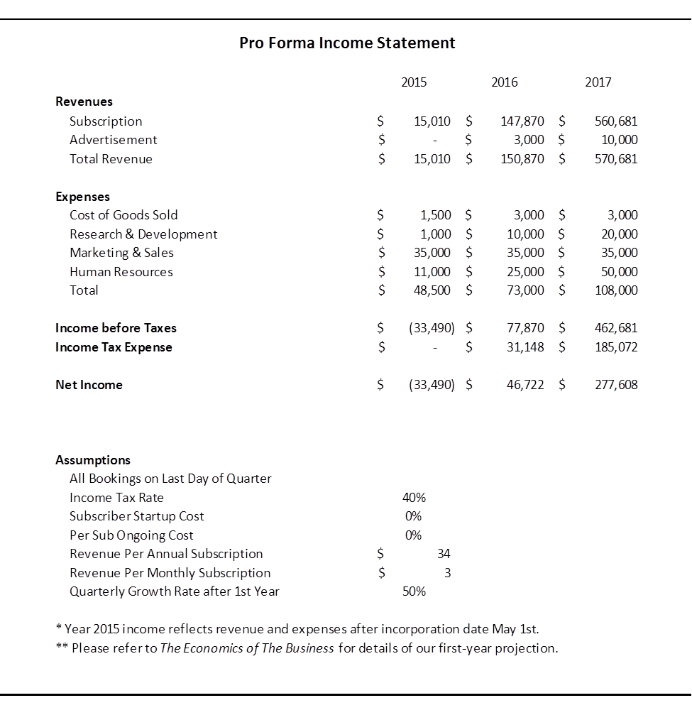

1. **Pro Forma Cash Flow Analysis Statement**

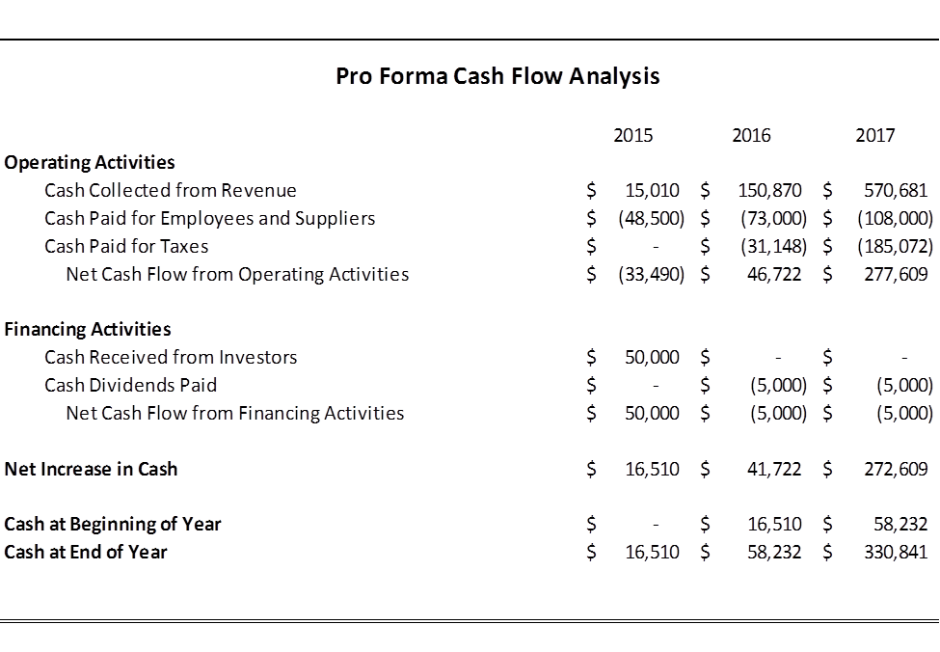

1. **Break-even Time**

We are aiming to achieve break-even within at most 24 months. Based on the projection by our Chief Financial Officer, our company would be able to reach break-even after in 21 months. As shown in the graph below, after 21 months the income would exceed cost. In order to achieve this goal, we need to further adjust out pricing and variable cost as the market fluctuates. Based on the analysis of our Marketing Manager, it is promising that we can reach break-even before this expected date.

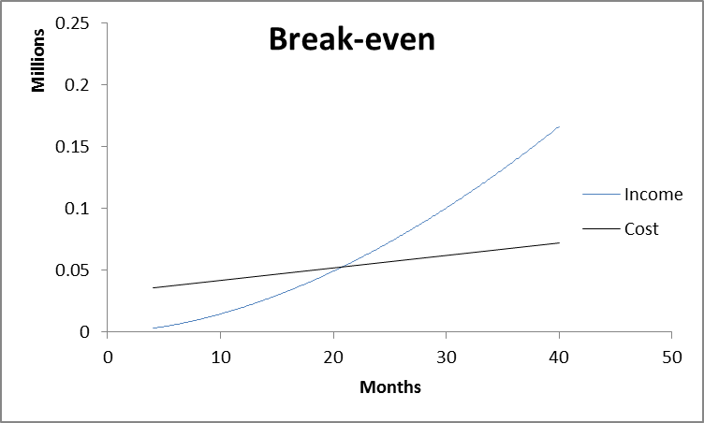

Achieving break-even is promising given our company’s low cost nature and our potential in cooperating with corporate users, which would further extends the rate of increase in income beyond current projection.

1. **Cost control**
2. Monthly Cost Report

The CFO generates report on costs on monthly basis and then reports to the CEO with analysis and suggestions. The report of costs would be reviewed and discussed by all key management personnel.

1. Actions by Each Department

The CFO would discuss with the managers of different departments on plans on cutting cost and keep track on the actions taken by each department.

1. **Highlights of Financial Plan**
2. Equity

We would like to invite interested parties of venture capitals to help us with funding for expanding markets. We are expecting $50,000 of initial funding as equity, consisting 40% of total assets.

1. Co-founders’ Efforts

Co-founders would contribute to the starting stage by developing product and designing business model. Our co-founders agreed that for the first round investment, we need no funding other than the $50,000 from equity given the low cost of our business model. Co-founders would hold 60% of total assets.

1. **Proposed Company Offering**
2. **Desired Financing**

At the stage of initialization, we are requesting $50,000 of outside funding to support the expansion and development of our company. Afterwards, we would like to have additional loans of at most $20,000 based on the need of funding during expansion. We would insist cost reduction in order to avoid unnecessary cost.

1. **Offering**

We are planning on offer 40% of equity to investors and the annual rate of dividends would be expected to be 10% starting from the second year of incorporation.

1. **Use of Funds**
2. We would use funds for hiring appropriate employees based on the business strategy of our company.
3. Funds would be allocated to Sales Manager on expanding market.
4. CTO would report funding request for hiring two full-time software engineers.
5. CFO would generate reports on use of funds on monthly basis to both the CEO and all equity holders.
6. **Investor’s Return**

Based on the Pro Forma Income Statement, at the end of the year 2016 investors would receive return on equity of 93.4% as well as 10% dividends on their equity.

1. **Overall Schedule**

The Cash Conversion Cycle and our detailed schedule are shown below.

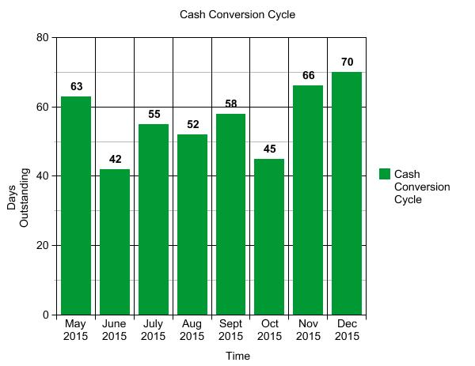



1. **Appendixes**
2. **Potential Source of Reference**

* Learn Piano HD (iOS App for promotion)
* Tiny Piano (iOS App for promotion)
* University of Chicago Library (Chopin Piano Scores) :http://chopin.lib.uchicago.edu/
* The Coral Public Domain Library (Free public domain scores by Chopin): http://www3.cpdl.org/wiki/index.php/Main_Page
* Lester S. Levy Sheet Music Collection over 29,000 public domain scores): http://levysheetmusic.mse.jhu.edu/
* Free-scores.com (offer free score downloads): http://www.free-scores.com/index_uk.php3
* The Cyber Hymnal (free choir scores): http://www.hymntime.com/tch/
* California Sheet Music Project (over 2000 public scores): http://people.ischool.berkeley.edu/~mkduggan/neh.html

1. **Legal Consultant**

* Oshan & Associates, P.C. (A law firm based in Seattle that provides legal consulting for technology startups. Our team has connection with a lawyer at the firm.)